**Day 6 Assignment**

1. Create payload for windows, transfer payload to victim machine, Exploit the victims machine

Creating payload for windows using kali linux and git for windows

Enabling Ssh For Git

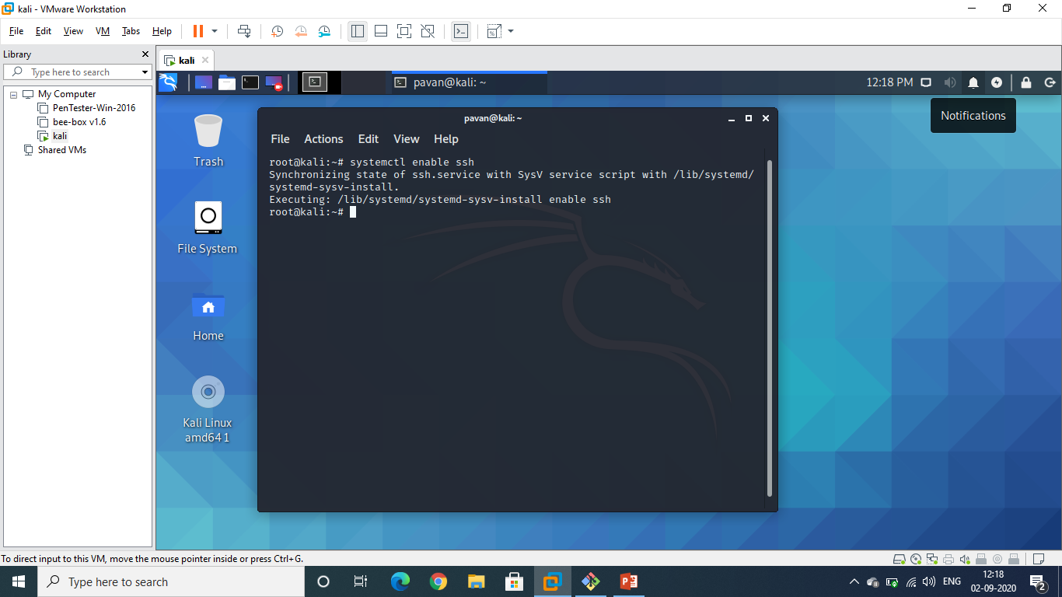

Commands In Git For Exploting

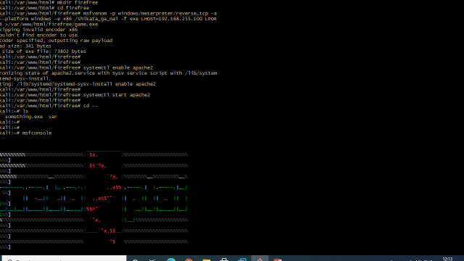

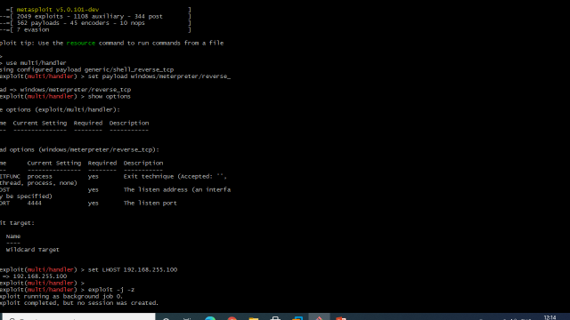

Accessing payload in victim machine using <url:-> <http://192.168.255.100/firefree/>

And download the pay load file and exploting machine

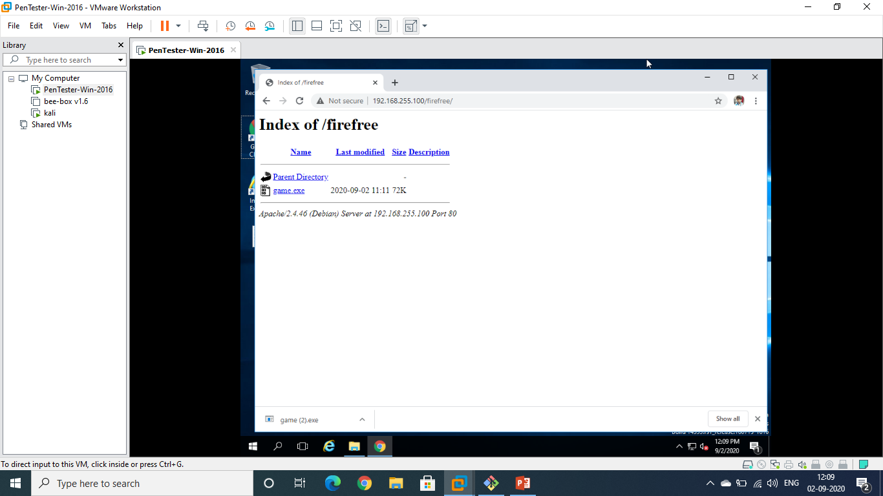

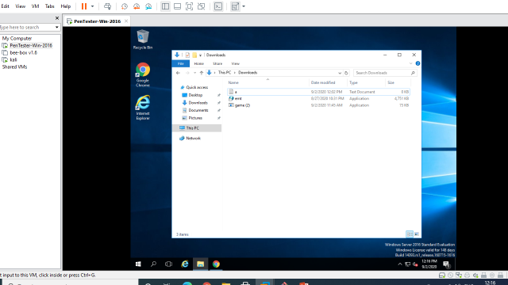

As soon as the victim try to install the payload in windows we get session activated for exploting.

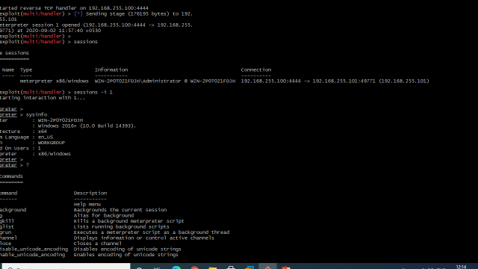

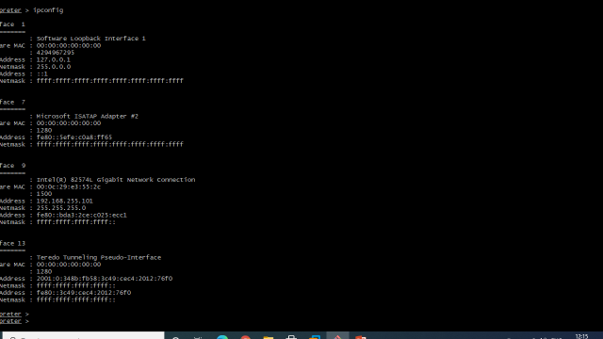

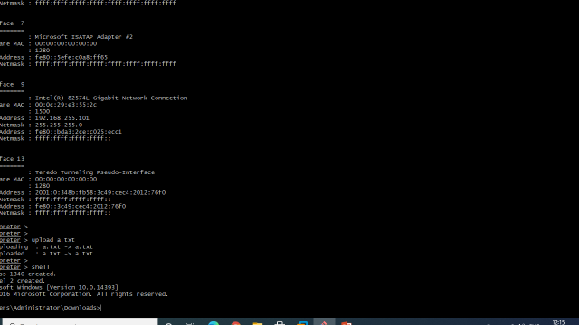

Finally as soon as the session has started we can get access the victim system using various cmds such as ipconfig, uploading, downloading etc.

1. Create an FTP server, Access FTP server from windows command prompt, Do an mitm and username and password of FTP transaction using dsniff.

Creating an FTP server:- In this exercise I am using Bee-Box as an FTP server

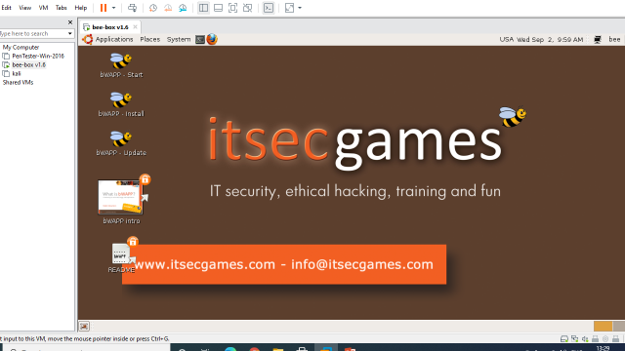

Accessing FTP server from command prompt in windows system.

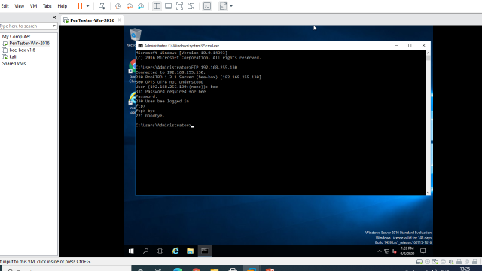

Doing an MITM attack to grab username and password of FTP transaction using Dsniff.

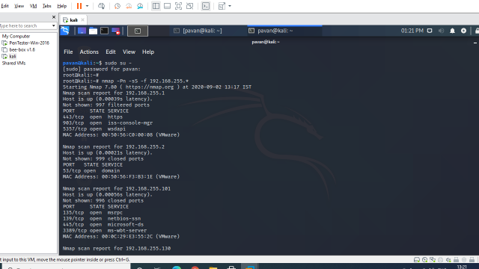

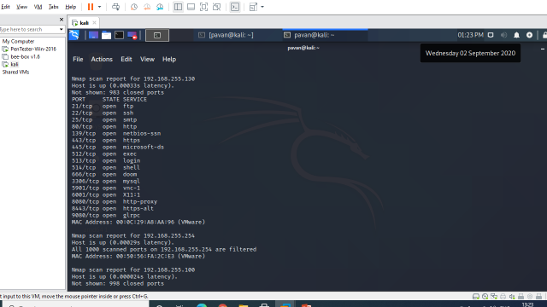

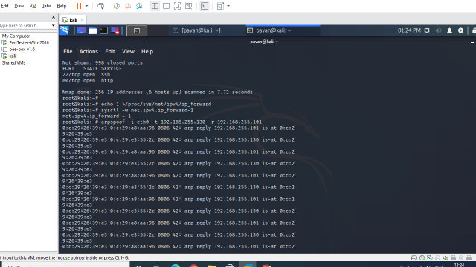

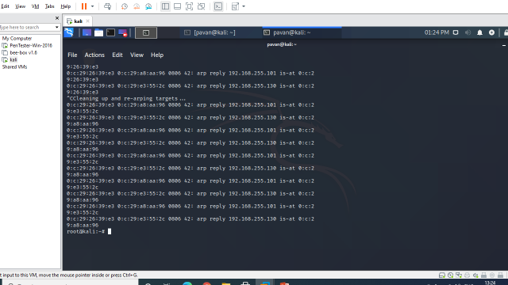

Using Dsniff for grabing userid and password.

